Why we have to monitor the bufferedAmount property
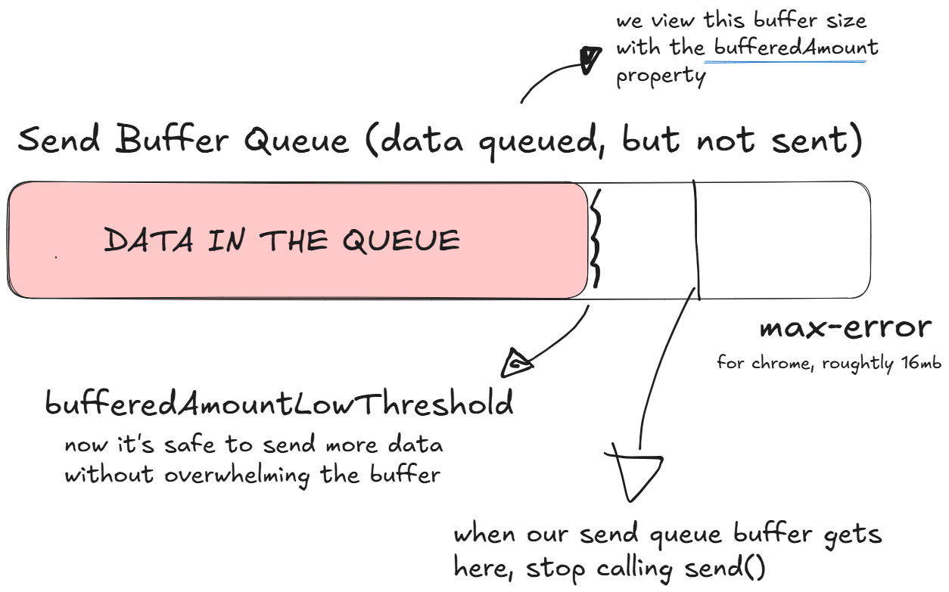
The bufferedAmount property of a WebRTC DataChannel shows how many bytes of data are currently waiting in the send queue to be transmitted over the network. Think of it as measuring how full that “outgoing mailbox” is at any moment. When you use the send() method to push data into the channel, it gets buffered if the network or peer can’t handle it immediately, so bufferedAmount rises.
Monitoring this value is crucial for flow control; if it gets too large, you risk filling the buffer and causing errors or stalling. To manage this, you can pause sending more data until bufferedAmount drops to a safer level, often indicated by the bufferedAmountLowThreshold property triggering a bufferedamountlow event. This way, you ensure smooth, reliable data streaming without overwhelming the channel.
Enough talk. Let's get coding.

